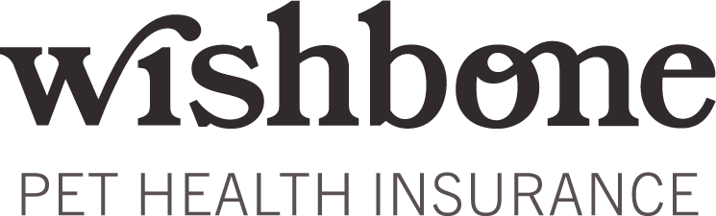

Wishbone Plan Descriptions for Employee Facing Materials
Wishbone disclosure provided to include below any of the plan descriptions if you choose to.
Please send screenshots or files to marketing@petbenefits.com for approval.

  - <50 words
Your pet deserves the best care, and you shouldn’t hesitate to give it to them! From accident and illness insurance for that trip to the emergency clinic, to affordable wellness plans that pay for routine care, Wishbone has your back.

Fetch a quote today!

  - <100 words
Your pet deserves the best care, and you shouldn’t hesitate to give it to them! From accident and illness insurance for that trip to the emergency clinic, to affordable wellness plans that pay for routine care, Wishbone has your back.

With Wishbone, you get:
- 70% reimbursement on accidents and illnesses
- A low $250 annual deductible
- Wellness plan options
- Fast claims processing
- Visit any licensed veterinarian
- Easy-to-use member account
- 24/7 pet telehealth
- And so much more!

Fetch a quote today!

  - <150 words
Your pet deserves the best care, and you shouldn’t hesitate to give it to them! From accident and illness insurance for that trip to the emergency clinic, to affordable wellness plans that pay for routine care, Wishbone has your back.

With Wishbone Accident & Illness Plans, you get 70% reimbursement on accidents and illnesses. Plus, chat with a veterinarian 24/7 with pet telehealth.

With Wishbone Wellness Plans, you get reimbursement on routine wellness care such as annual check-ups, vaccinations, preventatives, and more.

Both plans offer:

- Fast claims processing
- Visit any licensed veterinarian
- Easy-to-use member account
- And so much more!

Wishbone offers high-value, easy-to-use pet health insurance and wellness plans at exclusive employee benefit rates. Fetch a quote today!

Wishbone Disclosure:
Wishbone Pet Insurance is a pet health insurance program offered by Pet Assure Corp., dba Pet Benefit Solutions, a licensed agency (NJ License Number 1677880). Insurance coverage is administered by Pet Benefits Solution or Norse Specialty Insurance Company, Inc. and underwritten by Everspan Insurance Company, Providence Washington Insurance Company, Trisura Insurance Company, Clear Blue Insurance Company, or Clear Blue Specialty Insurance Company. Please visit https://www.wishboneinsurance.com/terms-and-conditions for more information. Wishbone’s wellness plans are not insurance and are administered by Pet Benefit Solutions.

Product information is descriptive; consult your policy or member agreement for specific coverage details. Terms vary by state and are subject to change. Coverage is determined by the applicable policy. Not all options are available to all customers. In case of conflict, policy provisions prevail.

